**ETL Project: Sugar Analysis**

By: Caitlan Beachey, Amaris Hassan, Cecilia Leung, Hillary Mandich, Kapir Pundhir

Date: December 19th, 2020

Contents

**1. EXECUTIVE SUMMARY** 3

**2. EXTRACTION** 4

2.1 FIND THE OPTIMAL DATASETS 4

2.2 DATASET SOURCES 5

2.3 RELATIONSHIP OF DATASETS 5

**3. TRANSFORMATON** 7

**DATA CLEAN-UP FOR CSV FILES** 7

3.1 REFORMATING COLUMN LABELS AND ROWS WITH ALL N/A 7

3.2 DELETING UNWANTED COLUMNS 8

3.3 COMBINING USEFUL INFORMATION FOR ANALYSIS 8

3.4 ADD COUNTRY CODE 8

3.5 CONNECT DATA BY INSERTING COUNTRY CODE 9

3.6 NORMALIZING 10

**B. DATA TRANSFORM USING PANDAS** 10

3.6 RENAMING COLUMNS 10

3.7 FILL NA 10

3.8 MELTING 10

# **1. EXECUTIVE SUMMARY**

ETL stands for Extract, Transform and Load. Extracting involves collecting, reading, and migrating large volumes of raw data from various sources into one easily accessible database. Transformation makes data meaningful by reformatting, filtering, transposing, merging, and joining. Finally, loading uses various applications/software to load the data into the faster and produce faster results.

ETL provides numerous benefits as it breaks down data silos by gathering all relevant data into one database. Another advantage is it greatly assist the Data Analyst to analyze the data and turn it into business intelligence. Finally, with data readily available, it helps you to make better decisions in a timely manner.

In this proposal, we have conducted the ETL process through our Sugar Analysis Datasets. We will explain how we completed the extraction, transformation and loading the data in the SQL Web Server using various techniques and applications. Finally, we will provide a summary of the process that will explain why we did what we did, limitations, and next steps.

# **2. EXTRACTION**

**This process involves finding and collecting datasets from various types of sources.**

## 2.1 FIND THE OPTIMAL DATASETS

Extracting the right data sources is the key to success in the ETL process. Without, the right data, we can make the wrong analysis about our topic.

We looked at what datasets we had from Project 1 and then decided to add new datasets to enhance our sugar data analysis.

Note that all the existing datasets have been extracted, validated, and transformed from Project 1.

We used a total of 5 CSV Existing and New Datasets from Kaggle that came from various sources like WHO, FAO, World Bank and Data . We were able to collect the data for at least 190 countries in each dataset.

The sources of our datasets are as follows:

## 2.2 DATASET SOURCES

|  |  |  |
| --- | --- | --- |
| **Dataset** | **Source** | **Website** |
| Sugar Intake | FAO | https://www.kaggle.com/angelmm/healthteethsugar?select=sugar_consumption.csv |
| Health Expenditure | WHO | https://www.kaggle.com/angelmm/healthteethsugar?select=healthexpend.csv |
| Income | Worldbank | https://www.kaggle.com/frankmollard/income-by-country |
| Obesity | WHO | https://www.kaggle.com/amanarora/obesity-among-adults-by-country-19752016?select=obesity-cleaned.csv |
| Country Codes | Data World | https://data.world/laurel/country-code-correspondence/workspace/file?filename=country_codes.xlsx |

## 2.3 RELATIONSHIP OF DATASETS

Before we proceed with any of the data clean up, we thought it would be a good idea to map out the relationship of the Databases.The perfect way is to map it out in an Entity Relationship Diagram (ERD) in http://www.quickdatabasediagrams.com.

Illustrating an ERD diagram is vital in database design because it:

* Increases understanding of how relationships and entities of the data.
* Decreases ambiguities and unnecessary processes.
* Outlines what applications and methods are needed to transform and load data.

See the below image to see how ERD of the Employee Databases.

**ERD Diagram:**

# **3. TRANSFORMATON**

**Transformation is the process of converting the extracted data from its previous form into the form it needs to be in so that it can be placed into another database.**

## **DATA CLEAN-UP FOR CSV FILES**

Data Cleaning involves reformatting the datasets to make sense of it. This could be removing irrelevant data, reformatting the data type, merging data, and looking up values to improve the data quality and usage before loading it up on the database. Having clean data is critical for decision making and data analysis.

The below steps show what we have done to clean the data in the CSV files.

## 3.1 REFORMATING COLUMN LABELS AND ROWS WITH ALL N/A

**HEALTH EXPENDITURE TABLE**

* Remove the “X” infront of the year
* Remove the rows with #N/A

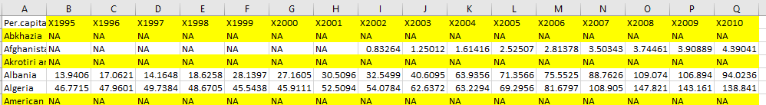

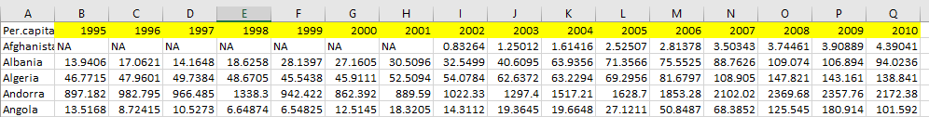

## 3.2 DELETING UNWANTED COLUMNS

**COUNTRY TABLE**

* Only one set of country code is necessary for performing data analysis.
* We only kept the ISO3 column and deleted the rest.

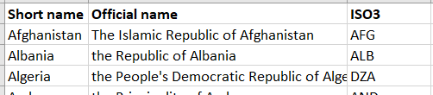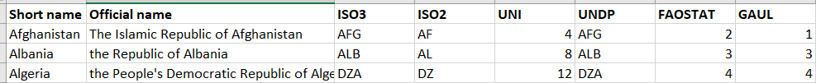

## 3.3 COMBINING USEFUL INFORMATION FOR ANALYSIS

**COUNTRY TABLE**

* Add columns, Continent and Sub-Regions through lookup tales
* [Need Hillary to confirm where those info came from]

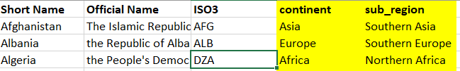

## 3.4 ADD COUNTRY CODE

**COUNTRY TABLE**

* Country code will be inserted in the first column of the Country table to identify each country as a unique value.
* First row will be 1, second row will be 2, and so forth.

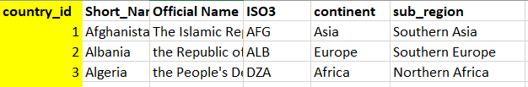

## 3.5 CONNECT DATA BY INSERTING COUNTRY CODE

**INCOME TABLE, OBESITY TABLE, SUGAR CONSUMPTION TABLE, HEALTH EXPENDITURE TABLE, COUNTRY TABLE**

* Open the country table, copy and move tab to each of the 4 tables.
* Add a country_id column on the leftmost side of each of the 4 tables.
* Conduct a LOOKUP to obtain the country ID for each country.
* Cannot have #N/A for country ID
  + If there is #N/A, determine if the country names on the respective tables match the country table..
* Upon completion, copy & paste value of country_id and remove country_codes tabs in the 4 tables
* Repeat this process for the Health Expenditures, Sugar Intake and Income tables

**Country Table (Lookup Value)**

**Obesity Table (Insert INDEX MATCH Formula on first column)**

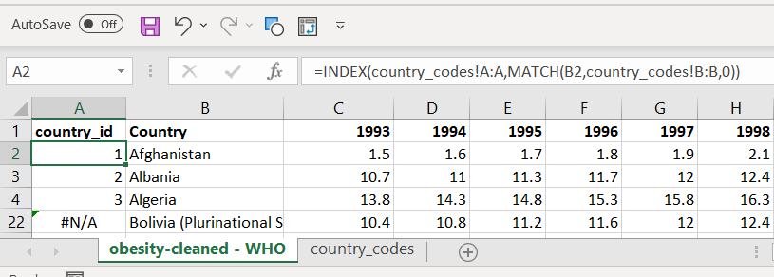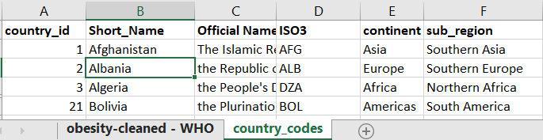



**Obesity Table (Get rid of #N/A by matching country name)**

**Country Table (Lookup Value)**

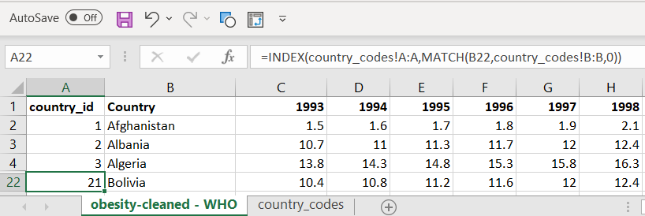

## 3.6 NORMALIZING

**INCOME TABLE, OBESITY TABLE, SUGAR CONSUMPTION TABLE, HEALTH EXPENDITURE TABLE**

* Since we have a country code as a unique identifier for each table, we do not need to have all the country names that may take up storage space.
* The country code will be the primary linkage to all datasets.
* Repeat this process for the Health Expenditures, Sugar Intake and Income tables

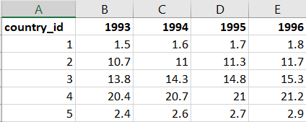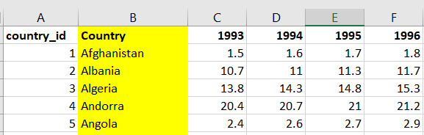

## 

## **B. DATA TRANSFORM USING PANDAS**

## 3.7 MELTING

## 3.8 FILL N/A AND “..” AS BLANK

## 3.9 INDEX COUNTRY CODE

# **4. CONNECTION**

## 4.1 CREATE DB IN ELEPHANT SQL

## 4.2 EXPORT ERD DIAGRAM FOR QUICK DATABASE

## 4.3 CREATE TABLES WITH HEADINGS IN TH ELEPHANT SQL DATABASE

## 4.4 USING PANDAS TO CONNECT TO ELEPHANT SQL

## 4.5 INSERT TABLE VALUES